The Nebraska Association of Teachers of Science is proud to announce the election of their newest board members. Congratulations, to

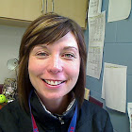 | NATS President-Elect  Betsy Barent  8th Grade Science Teacher and Middle School Department Head, Norris Middle School, Firth, NE
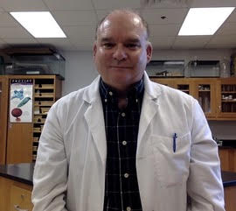 | NATS Secretary  Tim Hagge  Instructor Biological Sciences, Louisville High School
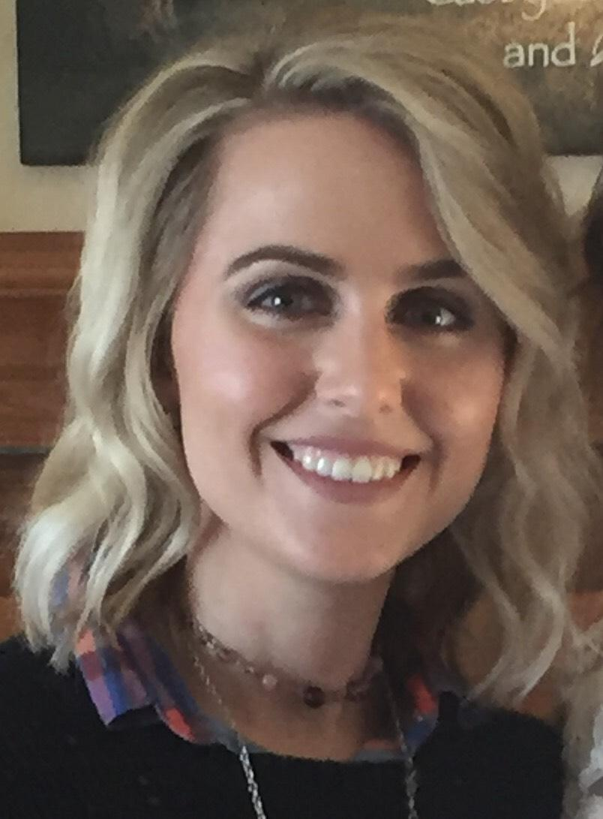 | NATS Board Member At Large  Rachel Burns  Advanced Placement Environmental Science, Honors Anatomy & Physiology, Plants & Propagation, Horticulture & Landscaping Teacher, Omaha Northwest High Magnet School
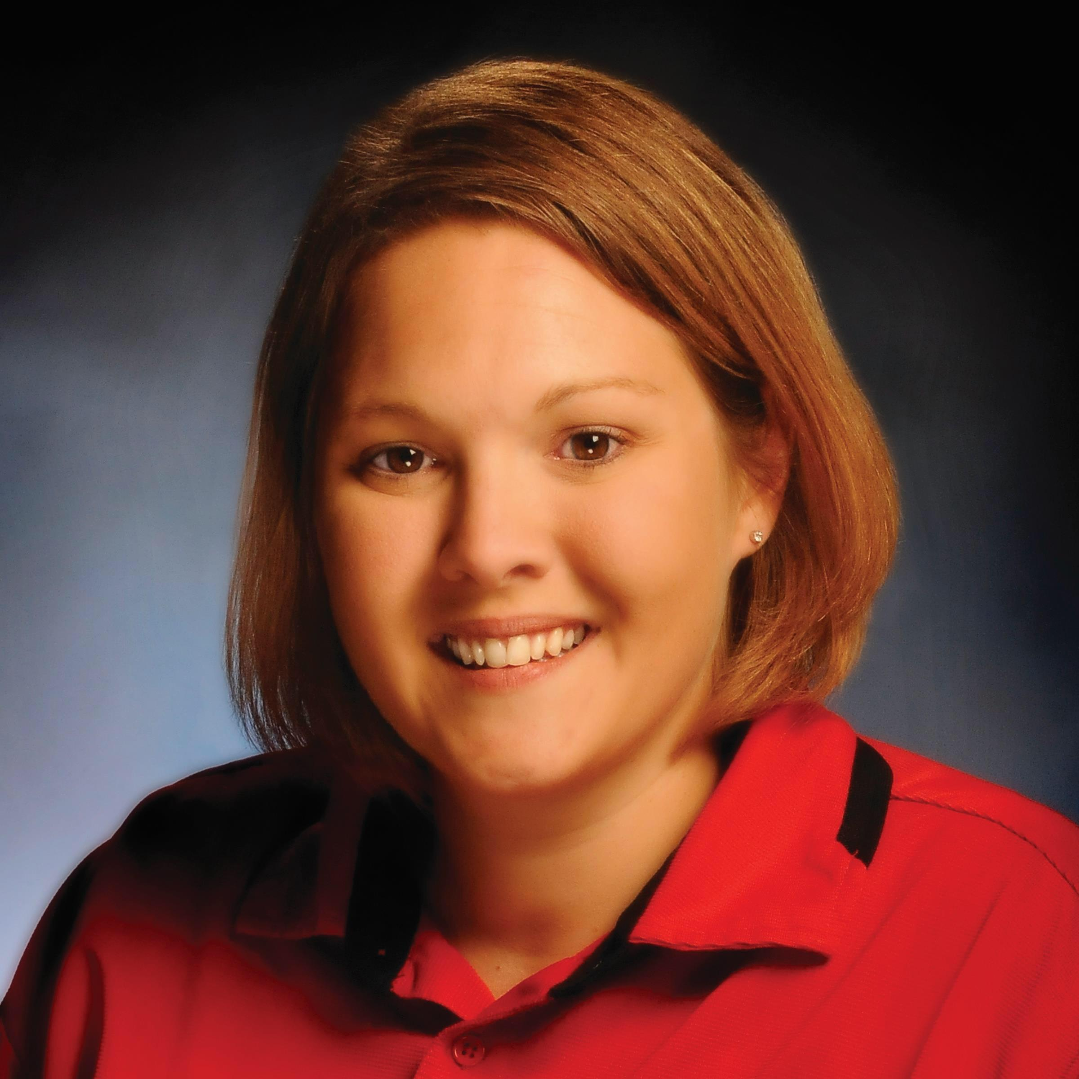 | NATS Board Member At Large  Jennifer Swerczk  Education Specialist, Nebraska Public Power District, Norfolk, NE

Thank you to the retiring board members

NATS Retiring Past President
Lee Broggie

Presidential Award Nominees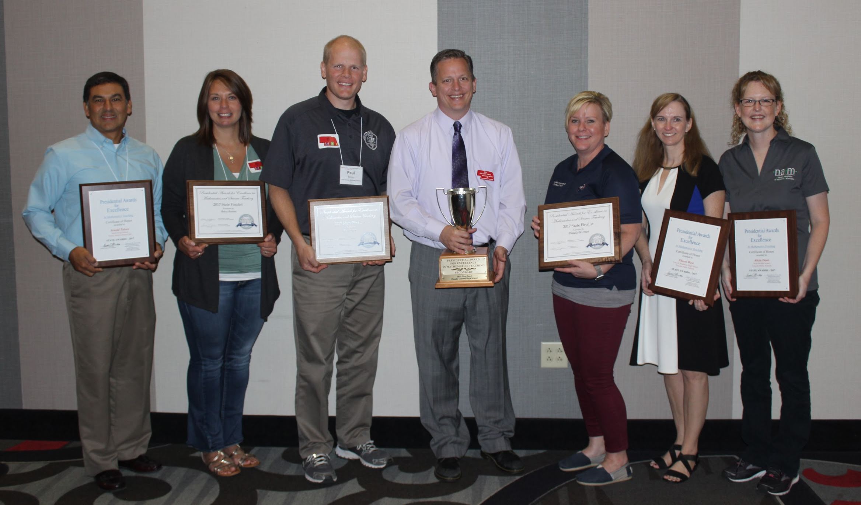
Left to Right
Arnold Tolero, Betsy Barent, Paul Timm, Gregory Sand (math 2015 national awardee), Pam Peterson, Sherri West, Alicia Davis
Cherrie Kerr was the other math finalist but I believe she did not attend due to having a baby.

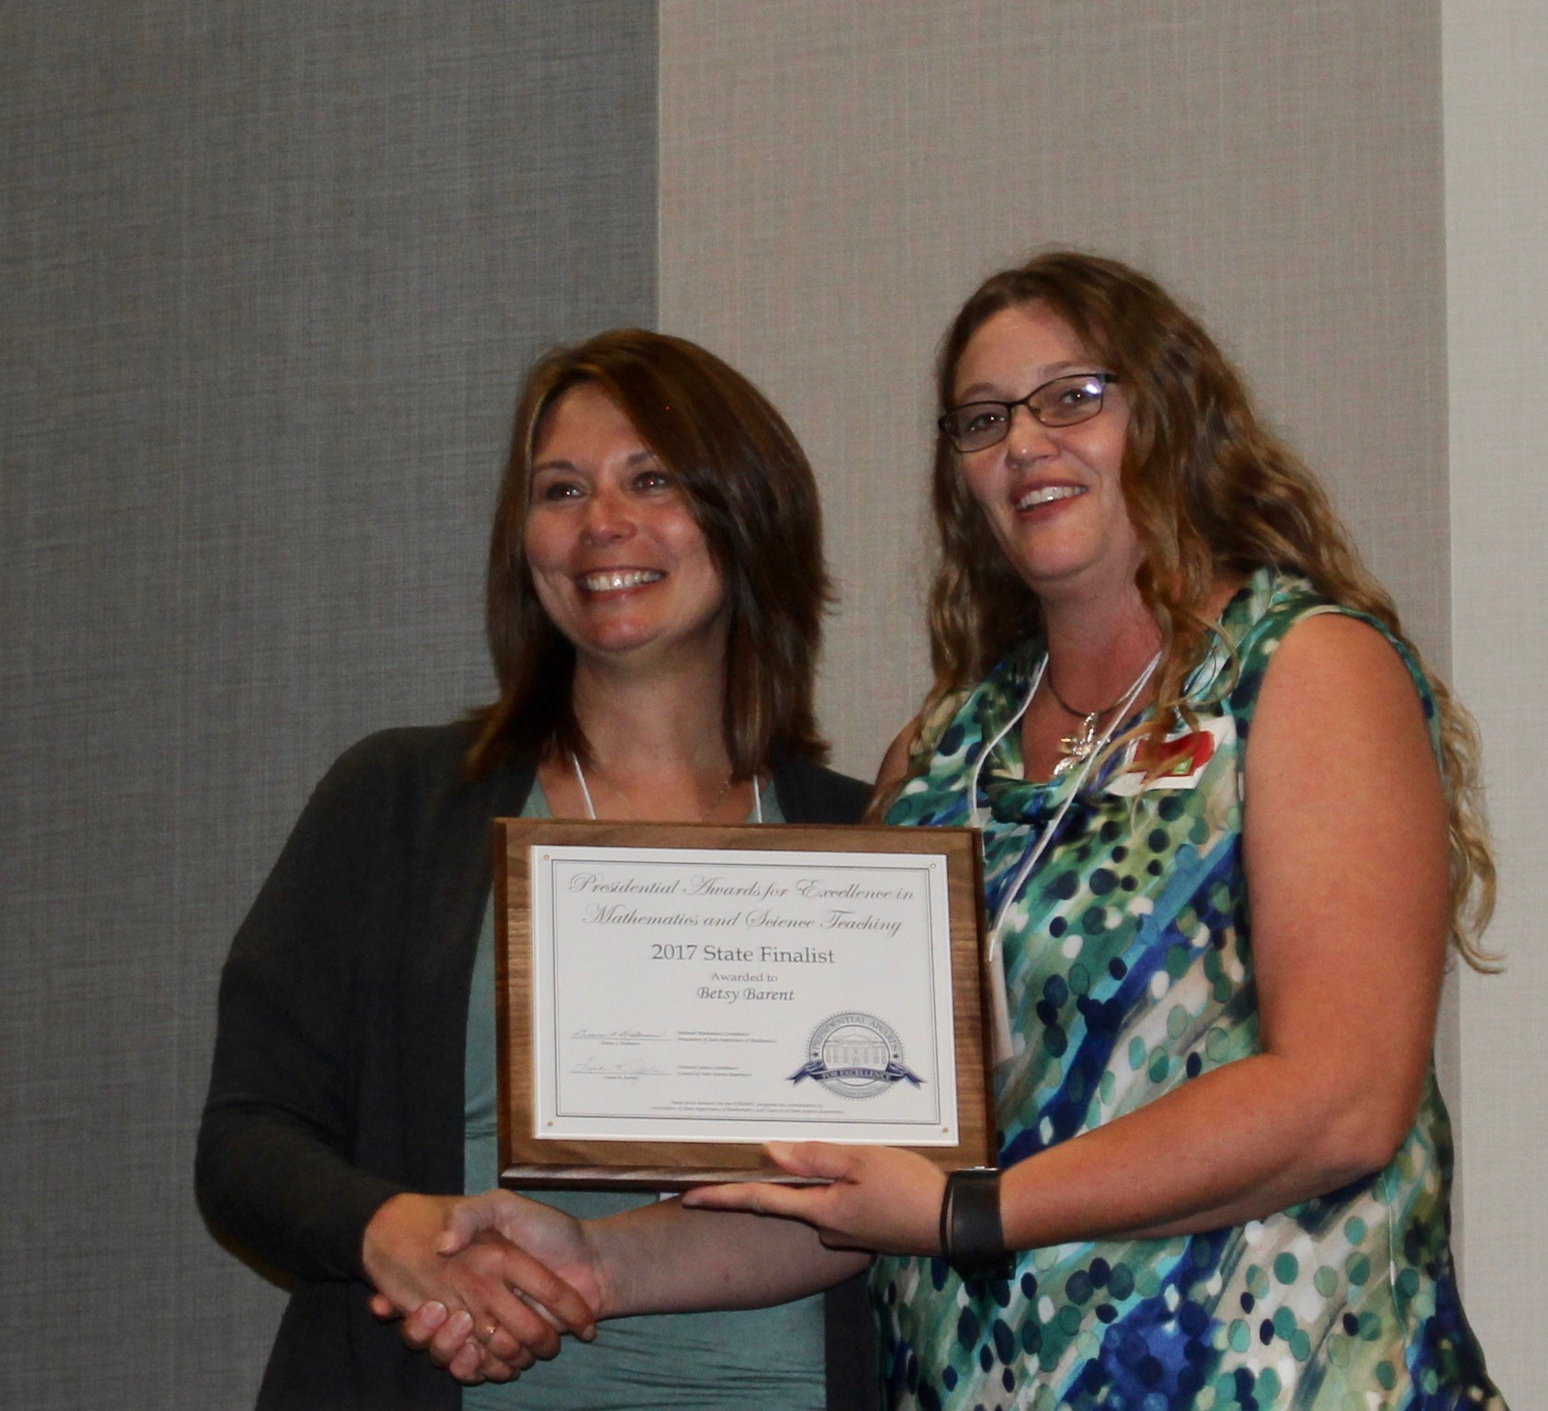 | Betsy Barent  8th Grade Science Teacher and Middle School Department Head, Norris Middle School, Firth, NE
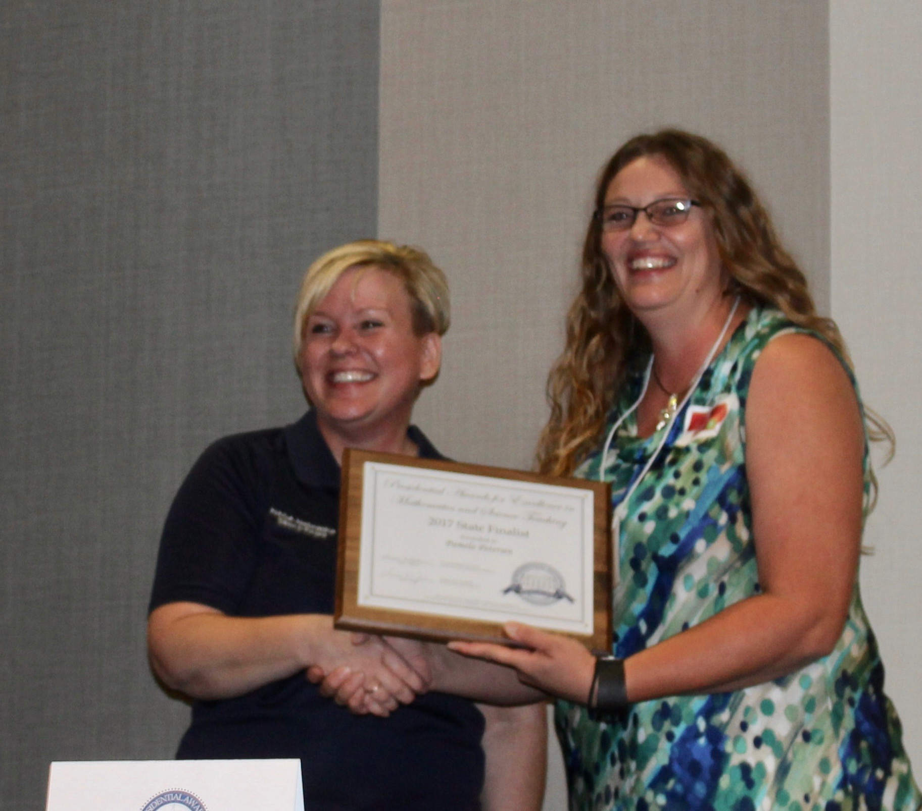 | Pam Peterson  Middle School Science Teacher at York Middle School
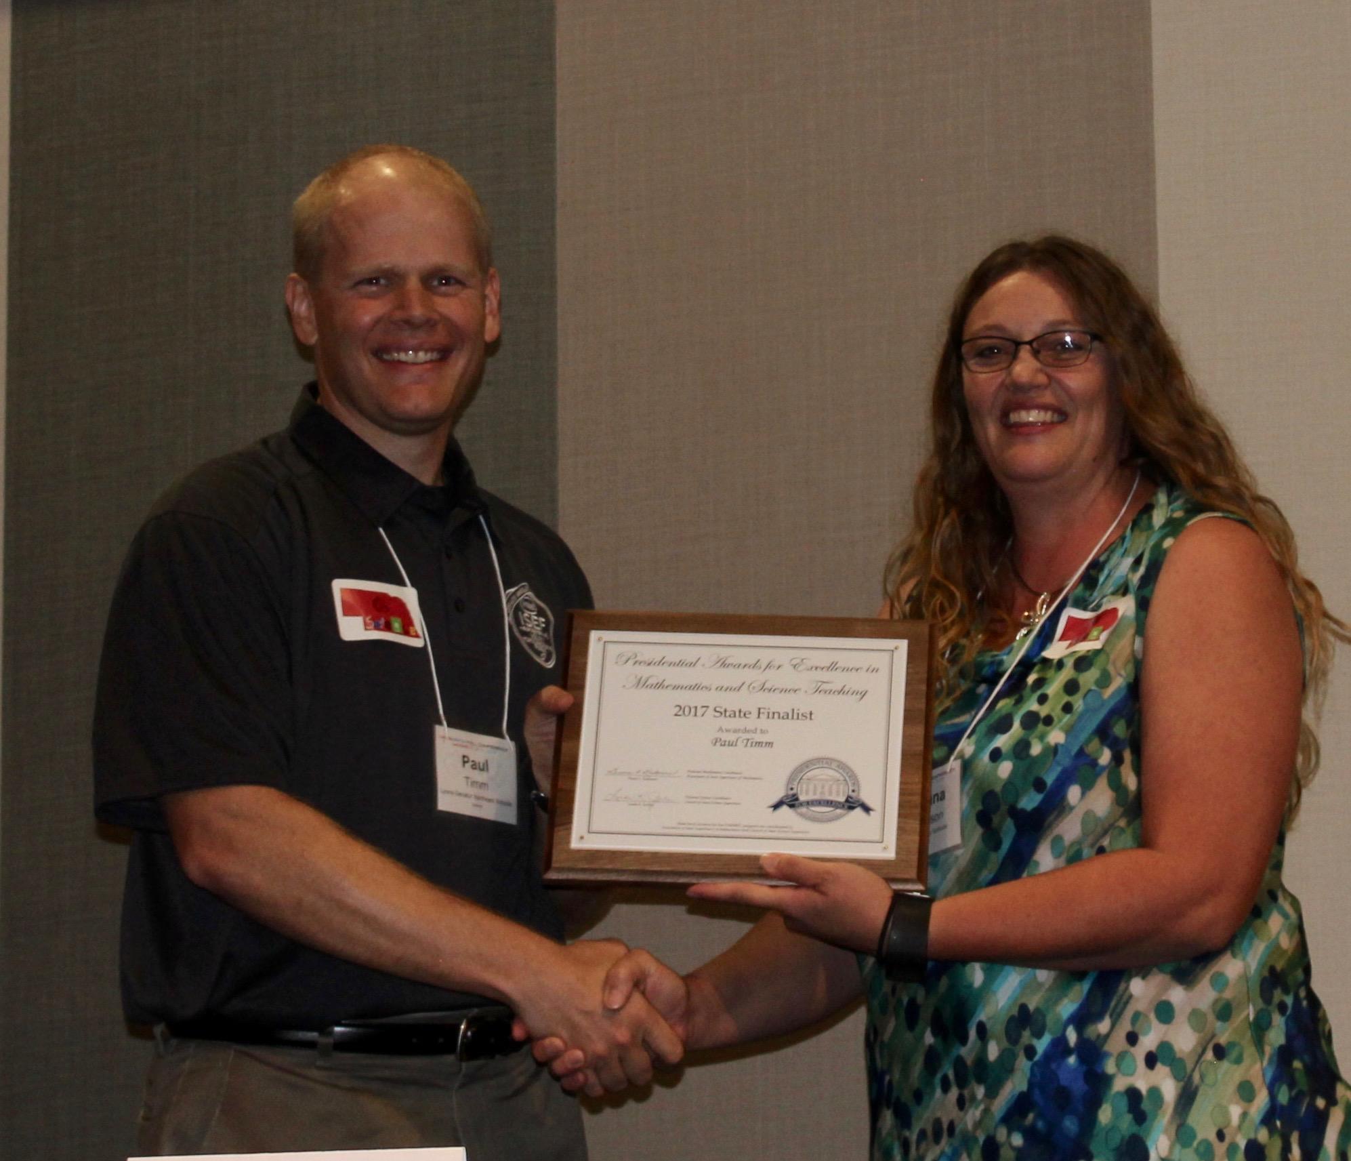 | Paul Timm  Secondary Science Teacher at Lyons-Decatur Northeast in Lyons, NE

Catalyst Award Winners
Catalyst awards are given to individuals that have promoted science education in the state of Nebraska.

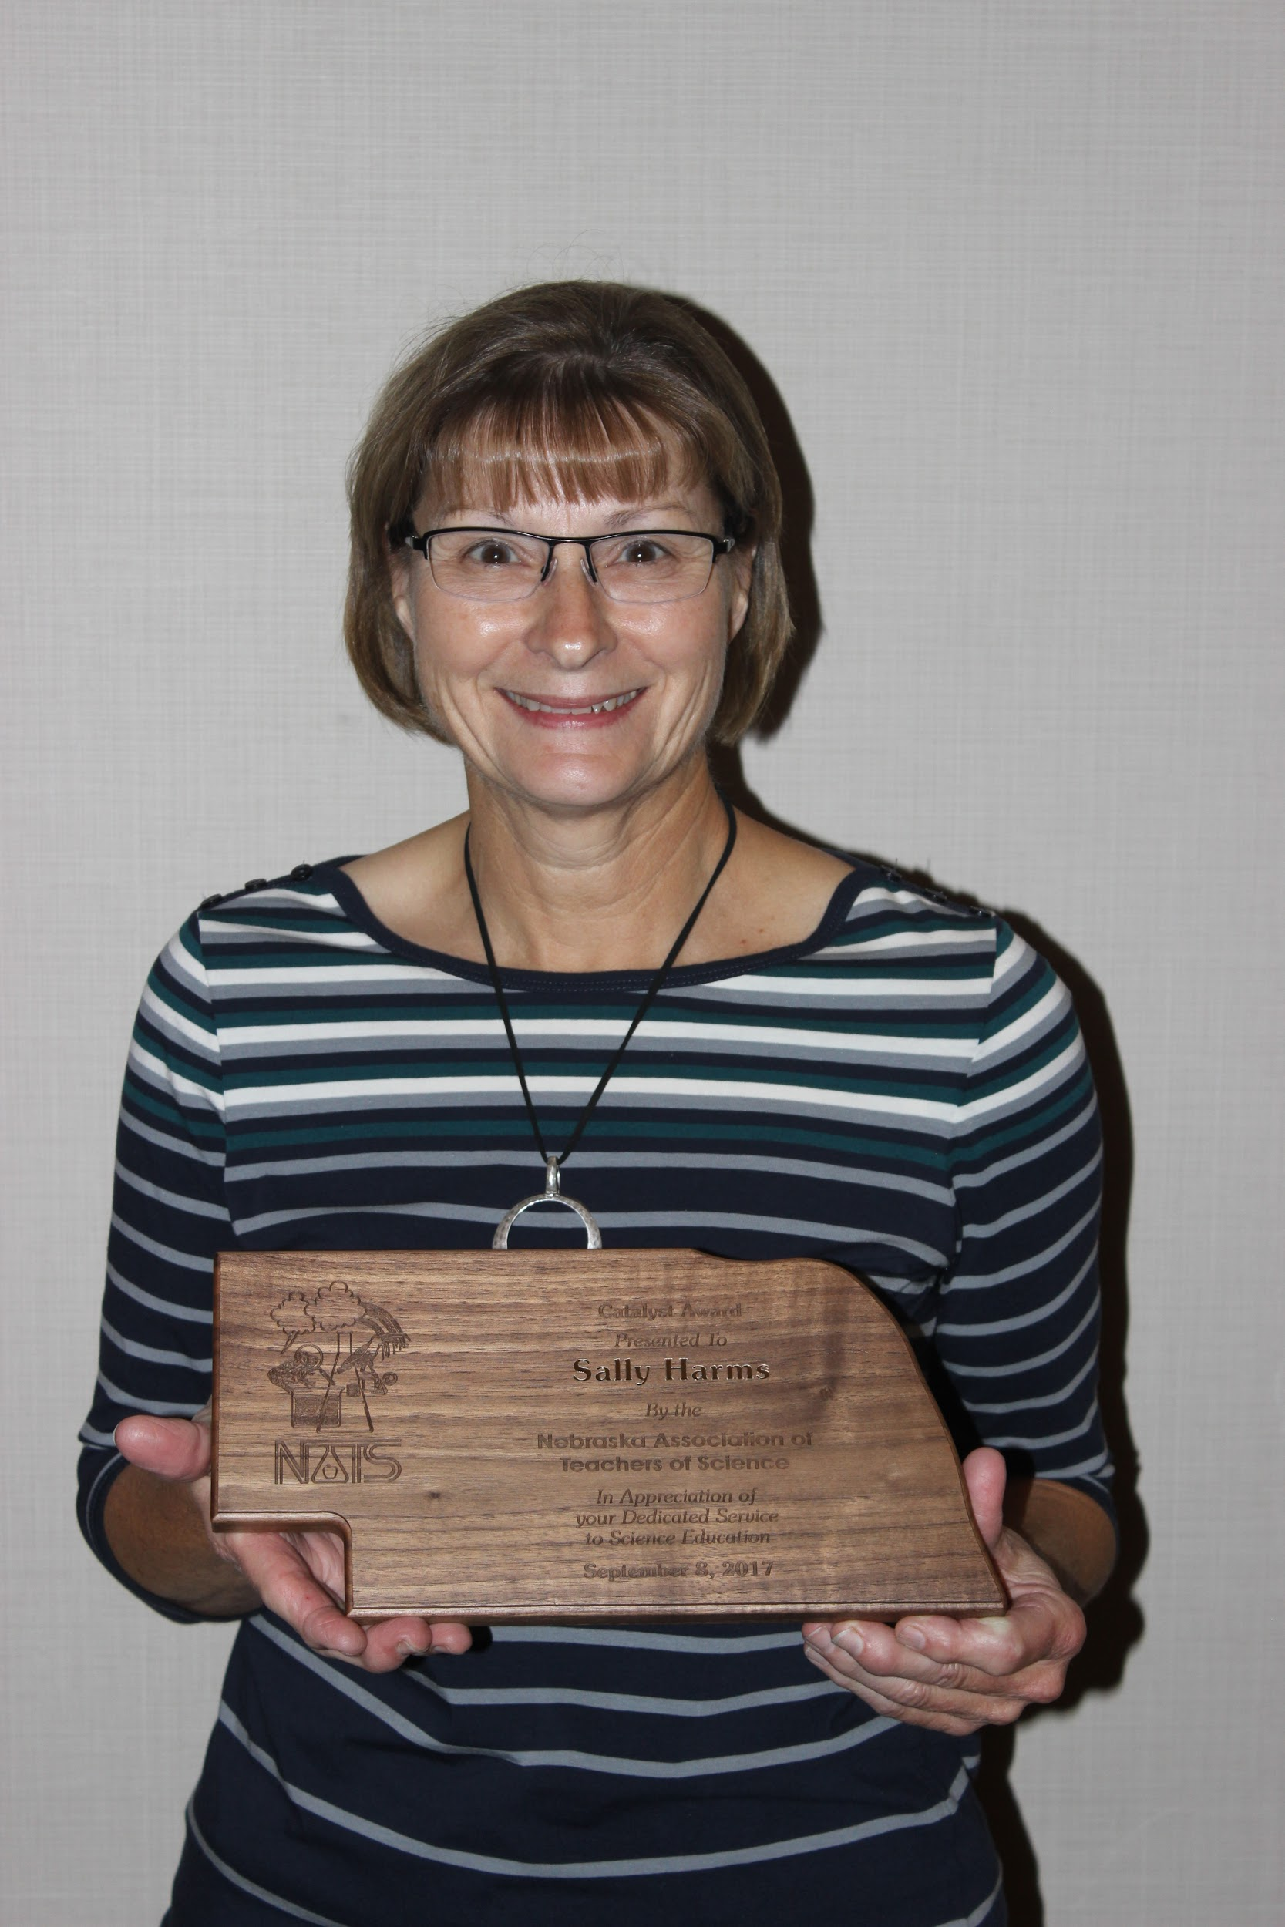 | Formal Educator Catalyst Winner  Sally Harms  Professor of Science and Science Education at Wayne State College  Sally has been a loyal member of NATS for over 30 years and served as a NATS president, an NSTA District Representative, and an NSTA district director. You will find many preservice teachers following Sally throughout the conference and we are grateful for her leadership in bringing these young teacher into the profession. Thank you Sally for you dedication to science education.
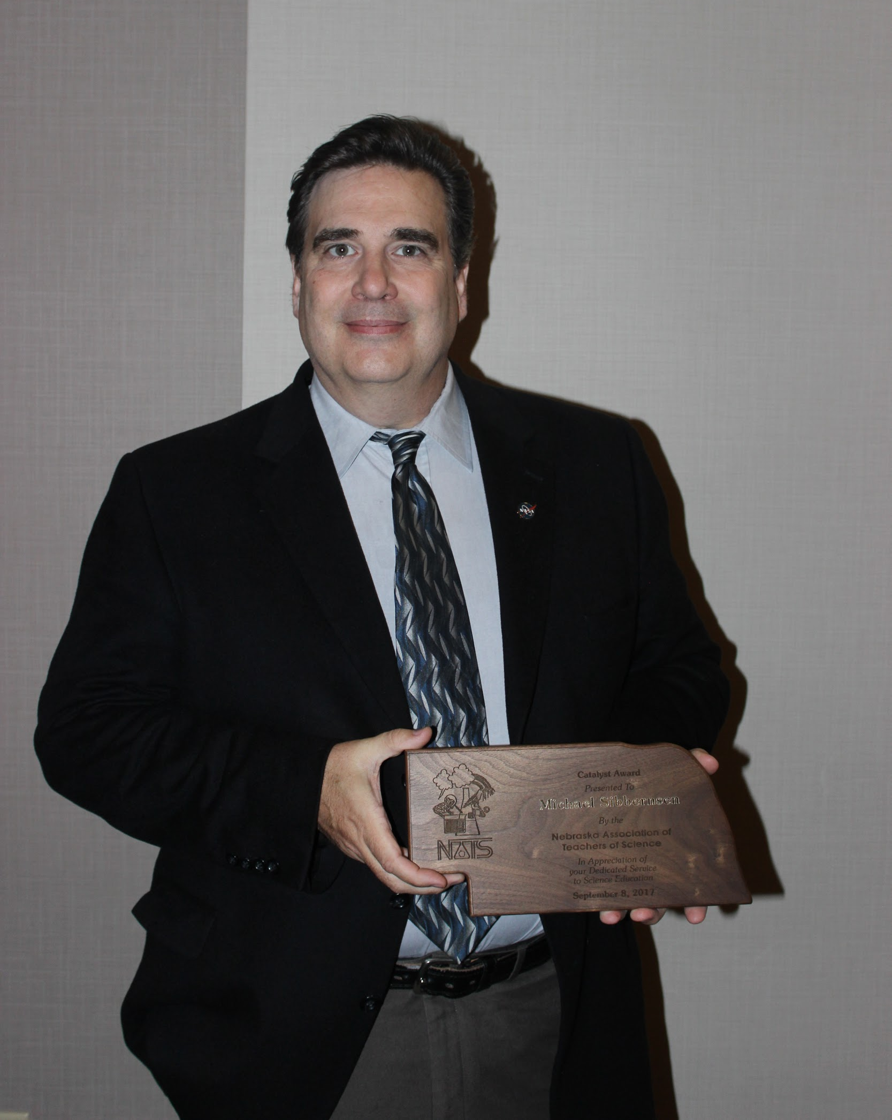 | Informal Educator Catalyst Winner  Michael Sibbernsen  Lecturer of Astronomy at the University of Nebraska-Lincoln  Before working at the university, he was the Science & Technology Coordinator for the Strategic Air & Space Museum, and before that, the Outreach Coordinator for the NASA Nebraska Space Grant office in Omaha. Over the years Michael has traveled throughout Nebraska performing hundreds of high energy hands-on science demonstrations for students of all ages. Michael has appeared on national television, and was for some time, a regular fixture as “the science guy” on a local morning talk show in Omaha. Many of you know Michael as the guy with the cool telescopes at the NATS star parties. Thank you Michael for all you have to promote science in Nebraska.

