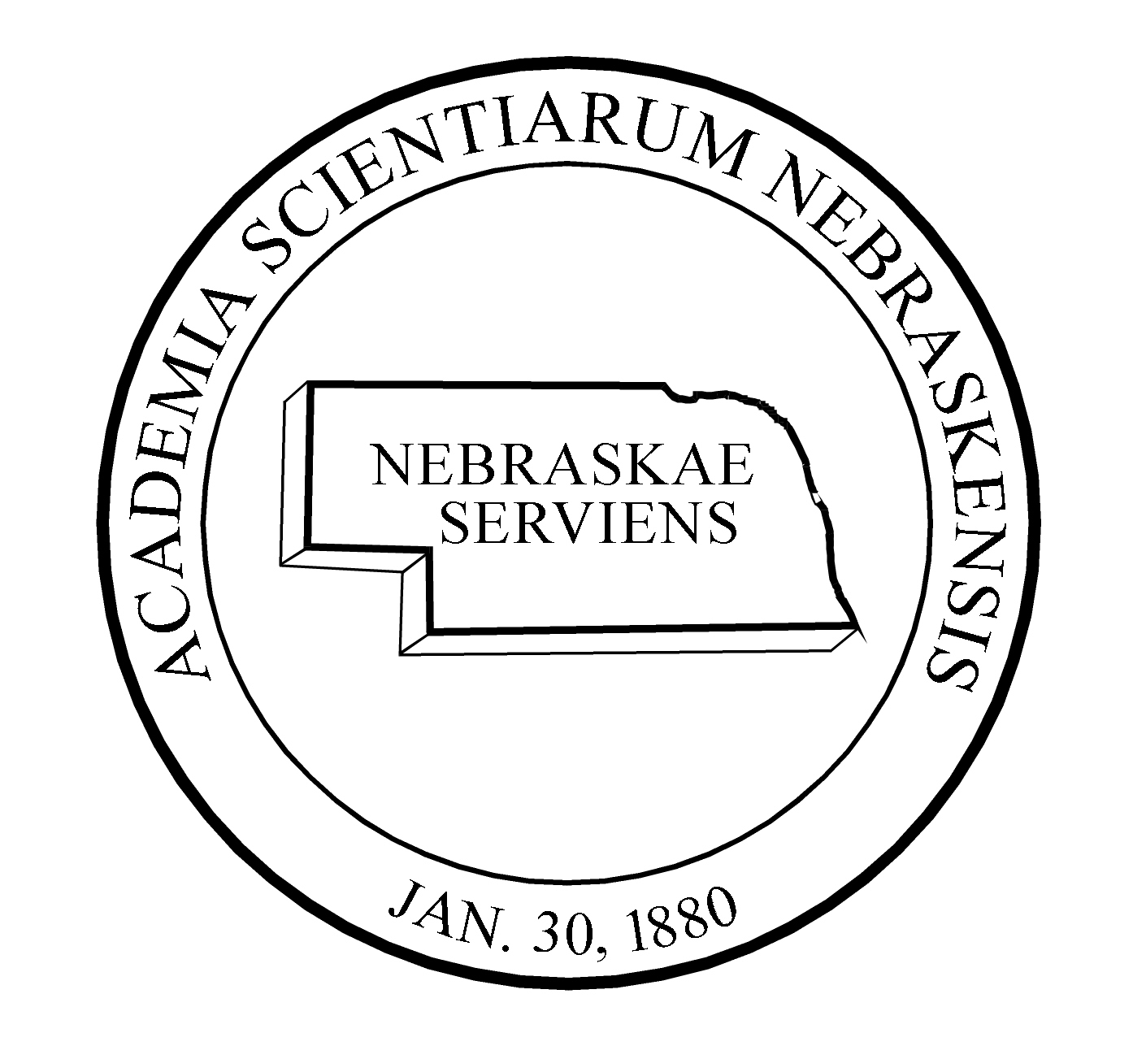NEBRASKA ACADEMY OF SCIENCES
PROGRAM COMMITTEE

Area code 402

Section Chairperson Address unless noted

Program Chairman & NAS, 302 Morrill Hall, Lincoln, NE 68588-0339 472-2644
Proceedings Editor nebacad@unl.edu

Aeronautics & Space Scott Tarry NASA NE Space Grant, 6001 Dodge St, 554-3772
Michaela Lucas CB 041, Omaha 68182-0589
mlucas@unomaha.edu & starry@unomaha.edu

Anthropology Taylor Livingston UNL, Dept of Anthropology, Lincoln 68588-0368 472-2411
tlivingston3@unl.edu

Applied Science & Mary Ettel Wayne State College, 1111 Main St, Wayne, 68787 375-7342
Technology maettel1@wsc.edu

Biological & Medical Annemarie Shibata Creighton Univ, Dept of Biology, Omaha 68178-0103 280-3588
Sciences annemarieshibata@creighton.edu

General Chemistry Joshua Darr UNO, Durham Sci 331, Omaha 68182 554-2653 jdarr@unomaha.edu

General Physics Adam Davis Wayne State College, 1111 Main St, Wayne, 68787 375-7339
addavis1@wsc.edu

Earth Sciences Irina Filina UNL, Dept of Earth and Atmospheric Sciences
Besy 223, Lincoln, NE 68588
ifilina2@unl.edu

Environmental Sciences Mark Hammer Wayne State College, 1111 Main St, Wayne, 68787 375-7043
mahamme1@wsc.edu

History & Philosophy of Vacant
Science

Teaching of Science & Josef Kren Bryan LGH Health Sciences, 5035 Everett, Lincoln 68506 481-4968
Mathematics josef.kren@bryanlgh.org

Junior Academy Randall Lienemann 1522 24 Rd, Hildreth, NE 68947 308-775-3320
rlienema@gmail.com

Collegiate Academy Therese McGinn Olin Hall of Science 208, NE Wesleyan 465-2457
(Biology) 5000 St Paul Ave, Lincoln, 68504
tmcginn@nebrwesleyan.edu

(Chemistry/Physics) Nathanael Fackler NE Wesleyan Univ., 5000 St Paul, Lincoln 68504 -2260
nfackler@nebrwesleyan.edu

NAS Exec. Secretary Betty Talley 302 Morrill Hall, 14th & U St, Lincoln 68588-0339 472-2644
nebacad@unl.edu

